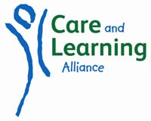

PERSONAL SPECIFICATION

Senior Gaelic Parent & Toddler Group Development Worker Leader
Criteria | Essential | Desirable
Good communication skills, interpersonal and in written. This must include fluency in spoken Gaelic language | 
Clean current driving licence | 
Childcare qualification e.g.: SVQ 3 Social Services (Children & Young People) at SCQF Level 7; HNC Childhood Practice or an equivalent childcare qualification |  | 
Computer literate | 
Ability to deliver Gaelic language learning activities to both children and adults | 
Awareness of Realising the Ambition, being me, Pre-Birth to Three: supporting our youngest children |  | 
Previous experience of supporting and advising Voluntary committees on all aspects of administration |  | 
Experience in community work |  | 
Awareness of GIRFEC and Child Protection processes | 
Proven experience and enthusiasm for supporting and being involved in Gaelic language and its development | 

