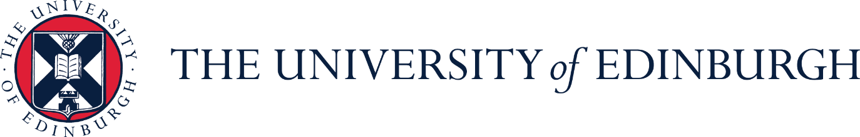

Job Description

Job Title: | Gaelic and Community Relations Officer
Department / School: | Communications and Marketing
Reports To: | Head of Public Affairs

Job Purpose

The post holder will be responsible for the implementation of the University’s Gaelic Plan 2025-2030, ensuring mainstreaming of Gaelic activities developed through the course of the Plan and to continue to promote Gaelic language at the University. They will also act as the secretary for the Gaelic Language Plan Working Group which includes cross-university representation.

The postholder will assist in developing and delivering resources required for communications – particularly, but not exclusively, those involving parliamentary, community and Gaelic stakeholders.

The post holder will also work as part of the Community Team – a team made up of colleagues in Communications and Marketing and the Department for Social Responsibility and Sustainability (SRS)– to support the implementation and communication of the Community Plan and associated activities.

Main responsibilities

Gaelic Officer (0.6FTE)

- Responsible for undertaking projects in order to meet the commitments outlined in the University’s Gaelic Language Plan, ensuring key stakeholders (internal and external) are aware of progress and any issues. Building on the Plan, they will be responsible for ensuring that Gaelic activities are mainstreamed into business as usual across the University and will manage the schedule and activity of the Gaelic Language Plan Working Group (GLPWG)

- Develop, improve and promote Gaelic-related academic, cultural and social activities and initiatives across the University with internal stakeholders in line with the Gaelic Language Plan. Collaborate with external partners to deliver projects and events linked to the University’s community commitments in the Gaelic Language Plan using appropriate internal and external channels as required.

- Evaluating and monitoring activity associated with the Gaelic Language Plan to demonstrate its impact, effectiveness and recommending amended plans as necessary to the Gaelic Language Plan Working Group. This will include planning and developing the new Plan when it is launched in 2024.

Community Relations Officer (0.4FTE)

- To support the Head of Public Affairs, and colleagues within the Community Team, to deliver the commitments within the University’s approved Community Plan 2025 - 2030. This will include organising the University’s Door Open Day programme and supporting the delivery of the Community Access to Rooms, Community Grants and Micro-grants schemes.
- Attending meetings, as required, of local stakeholder and community groups undertaking required actions and reporting on any relevant activity as required. Supporting the Community Team in their work will include occasional meetings or events at evenings or weekends.
- Gather intelligence and horizon-scan in order to be able to brief colleagues, as appropriate, on matters of potential interest to the University, including those in local communities.

Planning & Organising

- The role combines the work on the Gaelic Language Plan with support for community relations – this activity is only undertaken within the Stakeholder Relations team in CAM. The postholder will be required to balance their workload across multiple activities taking place at any time, planning effectively and efficiently.

- The postholder will be required to plan their own work activities to ensure effective delivery of activities and objectives outlined in the University’s Gaelic Language Plan and the Community Plan, while ensuring they are coordinating their work with colleagues across Communications and Marketing, and the Community Team.

Problem Solving

- As first point of contact, the post-holder will independently respond to queries relating to the University’s Gaelic Language Plan from staff, students, stakeholders and members of the public.

- Understanding and analysis of changing national and local Gaelic policies, trends and providing recommendations to the University on future responses.

- Awareness and involvement in local community initiatives which may impact on the University and ensuring they are communicated to the relevant internal or external stakeholders.

- Addressing problems and answering enquiries which arise in the course community relations work.

- Developing an approach to delivering ad-hoc projects and tasks, either independently or in collaboration with others.

Decision Making

- Providing informed recommendations on current and potential activities and initiatives across the University which are or could be of relevance to this post.

- Use judgement and initiative to progress main responsibilities on a day-to-day basis.

Knowledge Skills and Experience

Attribute | Essential | Desirable
Education, Qualifications & Training | - Either a relevant professional qualification or degree or substantial experience of demonstrating development in a progressively more demanding relevant work/roles  - Fluency in spoken and written Scottish Gaelic | - Social media skills  - Microsoft SharePoint proficiency  - Ability to write for the web and experience of publishing web pages
Knowledge & Experience | - Experience of communications work, with strong written and oral communication skills  - Excellent organisational, interpersonal and presentation skills  - Ability to work independently and with little supervision  - Knowledge of the University of Edinburgh, its structures and work | - Experience of working in a higher or further education setting  - Detailed knowledge of Gaelic language, culture and legislation  - Understanding of community relations and concerns within Edinburgh and Midlothian]  - Knowledge of political frameworks in the UK, in Scotland and at local level, and understanding of parliamentary processes

Dimensions

- Provide regular internal progress reports and an annual progress report to the Gaelic Language Plan Working Group and Bòrd na Gàidhlig.

- Build and maintain relationships with a wide range of organisations.

If you require this document in an alternative format, please contact HR by email at HRHelpline@ed.ac.uk or by telephone on 0131 651 5151.

